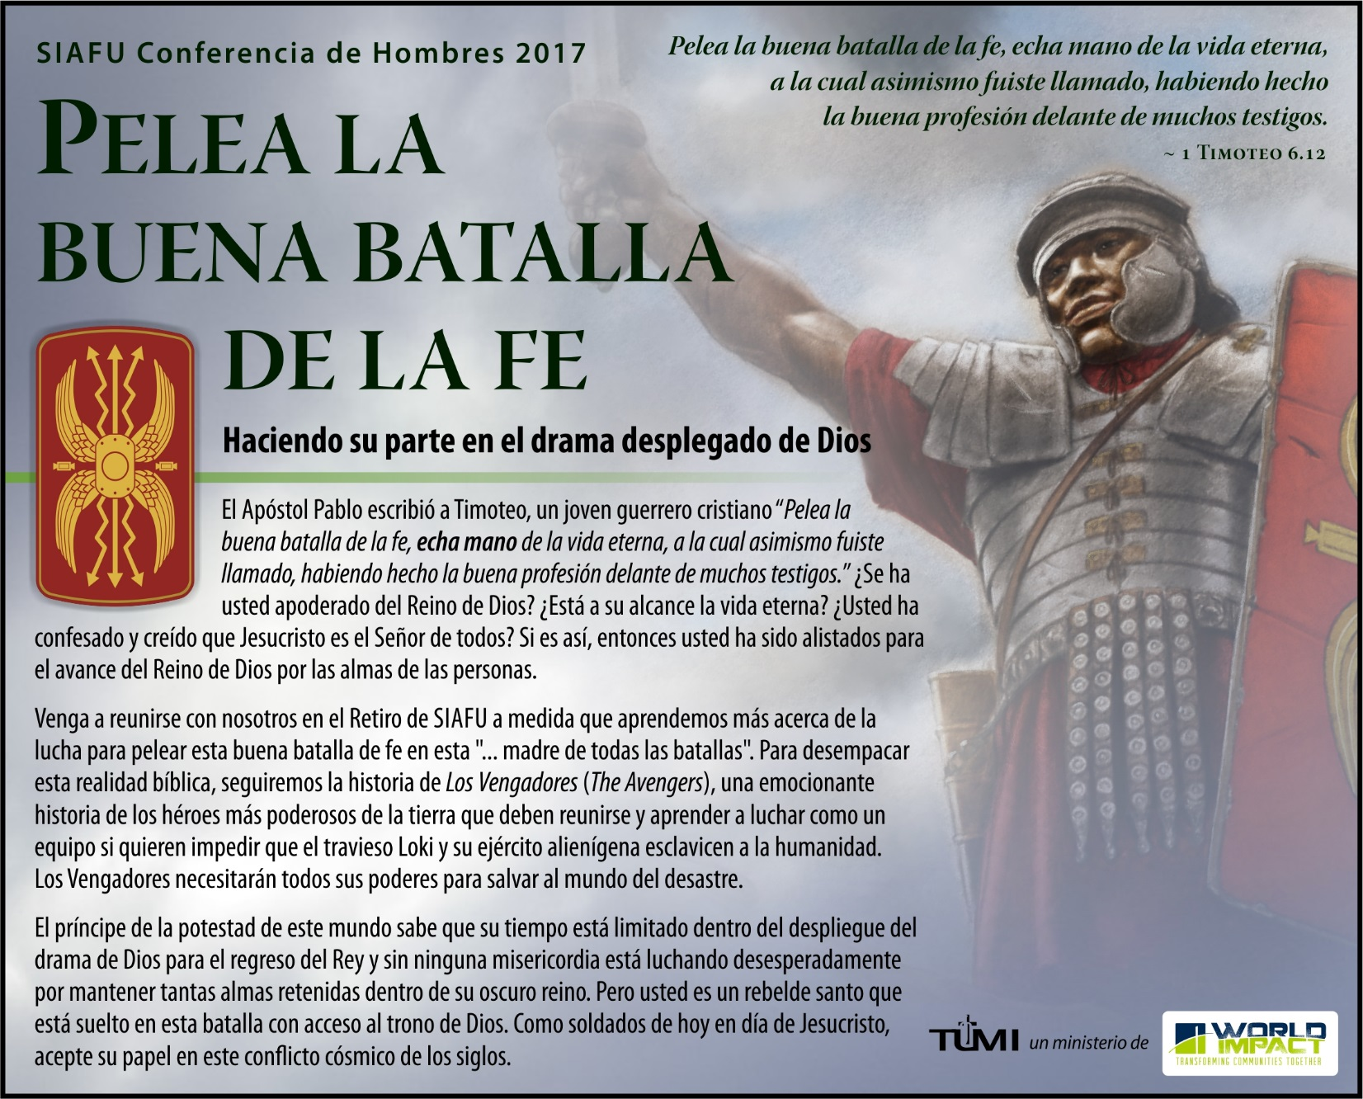
SIAFU Conferencia de Hombres 2017: Medio-oeste – Español
Cuando |  | Conferencista invitado
October 13-15, 2017 |  | Speaker’s Name  Enter brief biography of speaker here.
Dónde
Morning Star Ranch
1176 Banner Road
Florence, KS 66851
www.worldimpact.org/morning-star-ranch
Contacto | Andrew Medlen: amedlen@worldimpact.org
Online  Registration | www.tumi.org/siafu2017

