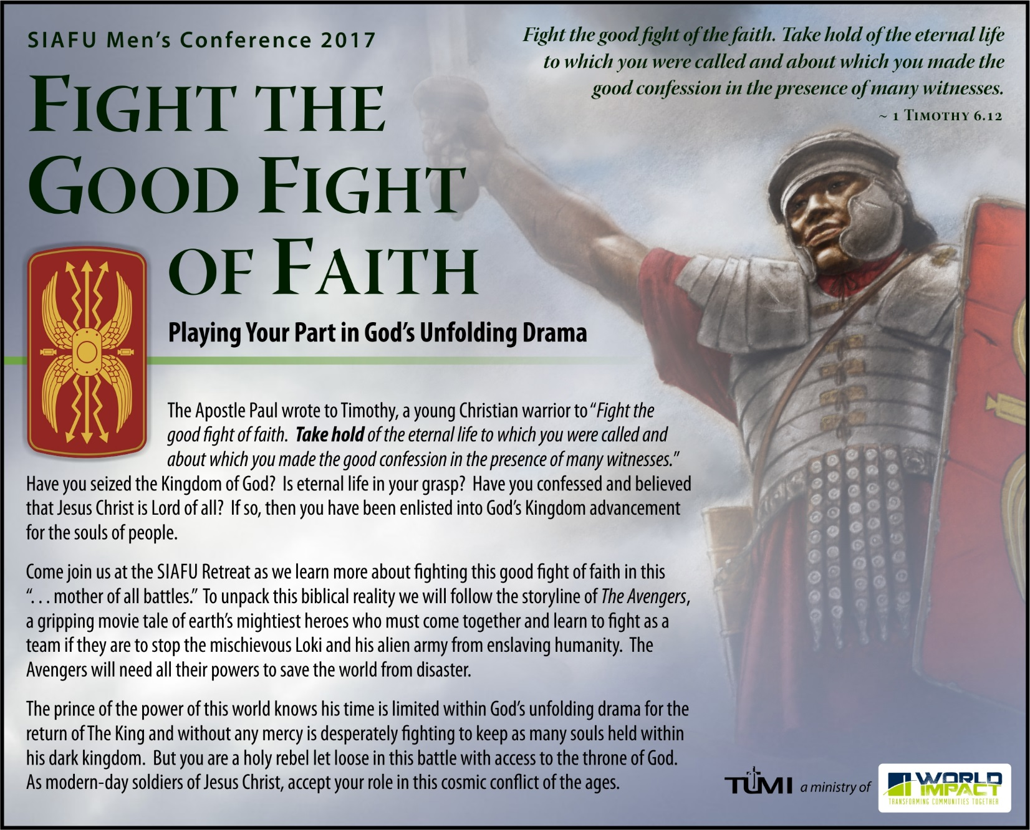
SIAFU Men’s Conference 2017: Midwest – English
When |  | Conference Speaker
October 13-15, 2017 |  | Rev. Dr. Don L. Davis  Dr. Davis is World Impact’s senior Vice President of Church and Leadership Development, as well as the Founder and Executive Director of The Urban Ministry Institute. He and his wife, Beth, have served in the city for forty-two years.
Where
Morning Star Ranch
1176 Banner Road
Florence, KS 66851
www.worldimpact.org/morning-star-ranch
Contact | Andrew Medlen: amedlen@worldimpact.org
Online  Registration | www.tumi.org/siafu2017

